**Construction Management**

**CE 417--Uddin**

**Term Project**

**William Rossell**

**Spring 2018**

**Executive Summary**

The following report will over view the methods of construction for a construction project proposed by Dr. Waheed Uddin. This report will define means of production, rates of production, and costs of production, as well as provide a bid as a Construction Manager for which the project would be rewarded. All cited works do not belong in any way to the author of this report, and I do not claim ownership of any kind.

Jobsite Requisite Information:

|  |  |
| --- | --- |
| Job Type | Scrape and Haul |
| Haul Material Type | Sandy Clay (Dry Earth) |
| Material Weight | 2,850 lb per bcy |
| Haul Road Condition | Well - Maintained |
| Resistance to Rolling | 35 lb per ton + Grade |
| Average Load Time | 0.80 min |
| Average Load Size | 90% Heaped Capa. |
| Machine Efficiency Rating | 55 min hour |
| Length of Haul | 3,000 ft |

Haul Road Properties:

|  |  |
| --- | --- |
| 700 ft | +3% Grade |
| 2,000 ft | 0% Grade |
| 300 ft | +4% Grade |

Machine Properties:

***This is an excerpt used from Peurifoy, Schexnayder, and Shapira’s Construction Planning, Equipment and Methods Edition 7. I claim no ownership of any material presented within. This information is being used for educational purposes only.***

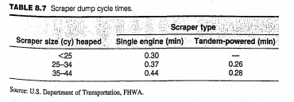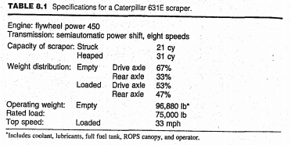

**Methodology**

The following calculation procedure lays out, in a step-by-step process, the methodology used in analyzes this job for proper equipment acquisition.

Step 1: Weight of Haul

$$\text{Empty Scraper Weight = 96,880 lb}$$

$$\text{Load Volume = 90\% Heap Cap. = 0.9 * 31 cy =27.9 loose cy}$$

$$\text{Material Swell Factor = 0.74}$$

$$Load Volume \left(bcy\right)= 27.9 lcy*0.80*1.1=24.55 bcy$$

$$\text{Weight of Load = 24.55 bcy * 2,850 }\frac{lb}{bcy}=69,973.2 lb$$

$$Total Gross Weight=96,880 lb+69,973.2 lb=166,853.2 lb$$

200 ft

dec.

200 ft

acc.

4%

100 ft

2,000 ft

500 ft

Fill

0%

3%

Haul

Return

Cut

Figure 1: Visual Representation of Haul Cycle Pathway

Step 2: Total Resistance

Based on the graphic above in Figure 1, the following table was made to denote total resistances during both haul and return legs of the production cycle.

Table 1: Resistance Measure of Production Cycle



Step 3: Travel Speed/Time

The figures in the following table are gathered from observing the proper scraper performance/retarder diagrams respective to the resistance (+ performance, - retarder). Due to the extremely low effective grade where the retarder chart is use, a top operating speed of 12 mph is assumed. Diagrams can be located below Table 2.

Table 2: Speed Measure of Production Cycle Table 3: Time Measure of Production Cycle

 

Total Time of Travel: 3.88 min

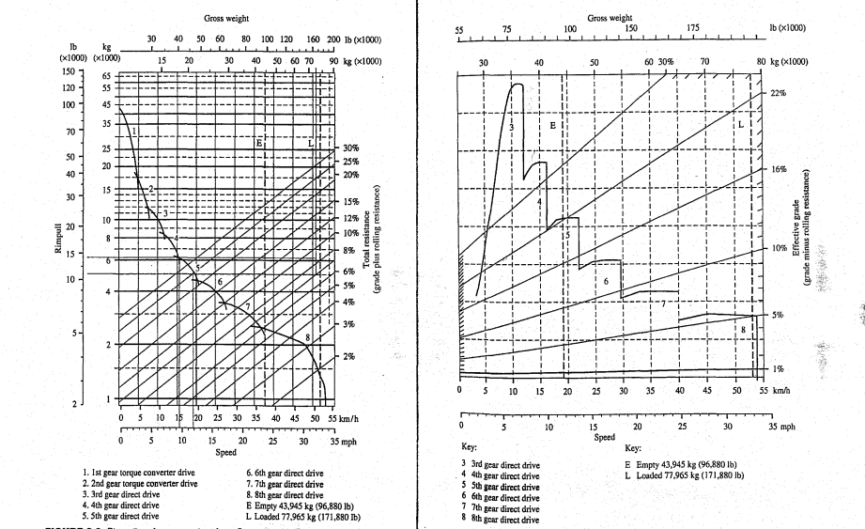

***This is an excerpt used from Peurifoy, Schexnayder, and Shapira’s Construction Planning, Equipment and Methods Edition 7. I claim no ownership of any material presented within. This information is being used for educational purposes only.***

Step 4: Total Cycle Times

Based upon figures observed and calculated throughout this process, the total cycle time will be the summation of the times for loading, hauling, turning, dumping, and returning.

$$Cycle Time \left(min.\right)=0.8+3.88+0.37+0.21+0.3=5.56 min.$$

**Results**

In this section, using information previously attained through an analysis procedure explain in the methodology portion of this report, the maximum scraper production rate, number of scrapers per one pusher, and controlling production rate of machinery for this job will be observed. This information is used to optimize the process and find what the best balance of working fleet is.

$$Max.Scraper Production \left(IDEAL\right)=\frac{24.55\frac{bcy}{cycle}}{5.56\frac{min}{cycle}}*60\frac{min}{hr}=264.92\frac{bcy}{hr}$$

$$Number of Scraper per One Pusher= \frac{5.56 min.}{1.4*0.8 min+0.25 min}=4.06 ≈USE 4 or 5 TBD$$

--The economics of using either 4 or 5 scrapers should be investigated.

Production Comparisons:

If the option of 4 scrapers is chosen, the scraper production rate controls:

$$Production Scrapers Controlling= \frac{55\frac{min}{hr}}{5.56 min}*4 scrapers*24.55\frac{bcy}{load}=971.4\frac{bcy}{hr}$$

If the option of 5 scrapers is chosen, the pusher production rate controls:

$$Production Pusher Controlling= \frac{55\frac{min}{hr}}{1.4*0.8 min+0.25 min}*24.55\frac{bcy}{load}=985.58\frac{bcy}{hr}$$

**Economical Comparison (Direct Cost Measures)**



Assuming Scraper Production Control:

$$Direct Unit Cost= \frac{\frac{\$101.00}{hr}*4+\frac{\$125.00}{hr}}{971.4\frac{bcy}{hr}}=\frac{\$0.545}{bcy}$$

Assuming Pusher Production Control:

$$Direct Unit Cost= \frac{\frac{\$101.00}{hr}*5+\frac{\$125.00}{hr}}{985.58\frac{bcy}{hr}}=\frac{\$0.639}{bcy}$$

Therefore, based on the economical analysis of this job detailing, it will be more profitable for 4 scrapers to be used at a slightly lower production rate.

Ultimate Direct Unit Cost is equivalent to $0.545 per bank cubic yard.

For this job, requiring an average 4-ft fill for a 500 ft by 900 ft area, the total direct cost is:

$$Direct Cost=\frac{4 ft*500 ft*900 ft}{27\frac{ft}{cy}}*\frac{\$0.545}{bcy}=\$36,333.30$$

This will require a project duration, utilizing 6 hour work days, of:

$$Workdays= \frac{\frac{4 ft*500 ft*900 ft}{27\frac{ft}{cy}}}{971.4\frac{bcy}{hr}*6\frac{hours}{workday}}=11.44≈12 workdays$$

The resulting bid amount for this project is displayed in the following chart:

